U18CO018

Shubham Shekhaliya

Assignment-5 (MIT)

**1->** A string of readings is stored in memory, locations starting at 2070H, and the end of the string is indicated by the byte 0DH.Write a program to check each byte in the string, and the save the bytes in the range of 30H to 39H (both inclusive) in memory locations starting from 2090H.

**Code: -**

**LXI H, 2070H**

**LXI D, 2090H**

**MVI C, 0DH**

**Start: MOV A, M**

**CMP C**

**JZ End**

**MOV A, M**

**CPI 30H**

**JZ Done**

**JC Next**

**CPI 39H**

**JZ Done**

**JNC Next**

**Done: STAX D**

**INX D**

**Next: INX H**

**JMP Start**

**End: HLT**

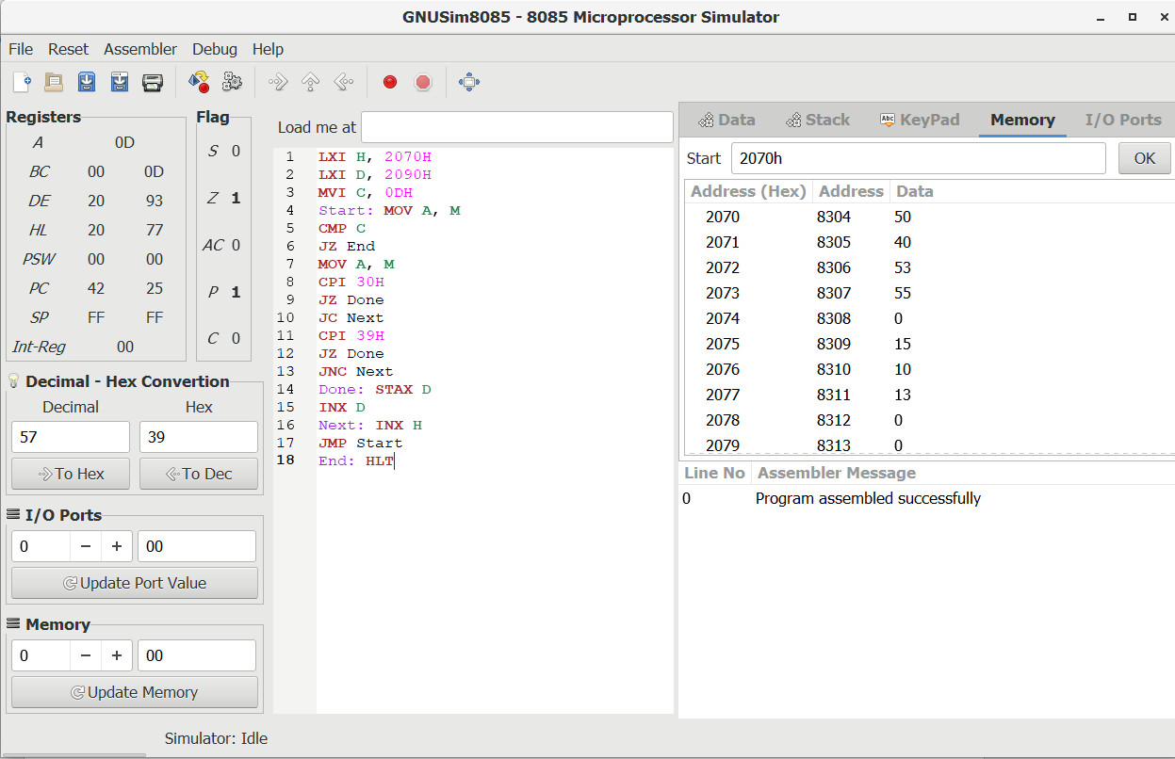

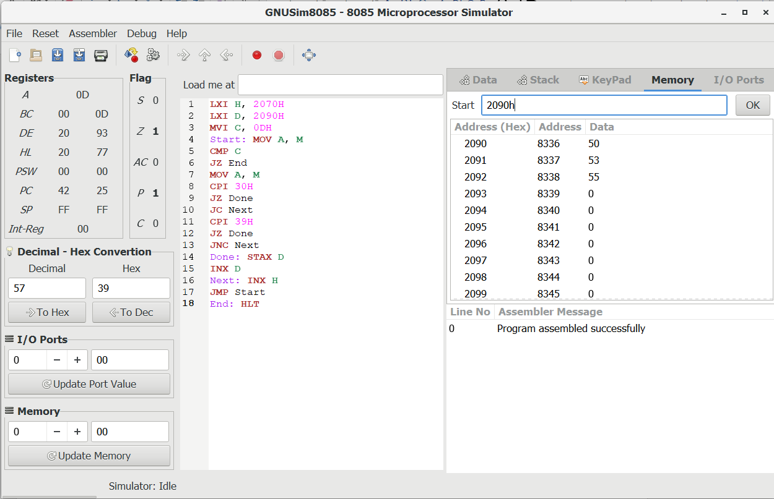

**2->** A set of ten bytes is stored in memory starting with the address 2050H.Write a program to check each byte , and save the bytes that are higher than 6010 and lower than 10010 in memory locations starting from 2060H.

**Code:-**

**LXI H, 2050H**

**LXI D, 2060H**

**MVI C, 10**

**Loop: MOV A, M**

**CPI 60**

**JZ Next**

**JC Next**

**CPI 100**

**JZ Next**

**JNC Next**

**STAX D**

**INX D**

**Next: INX H**

**DCR C**

**JNZ Loop**

**End: HLT**

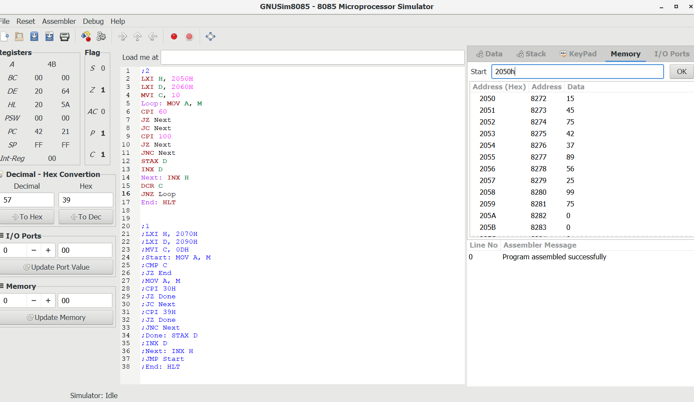

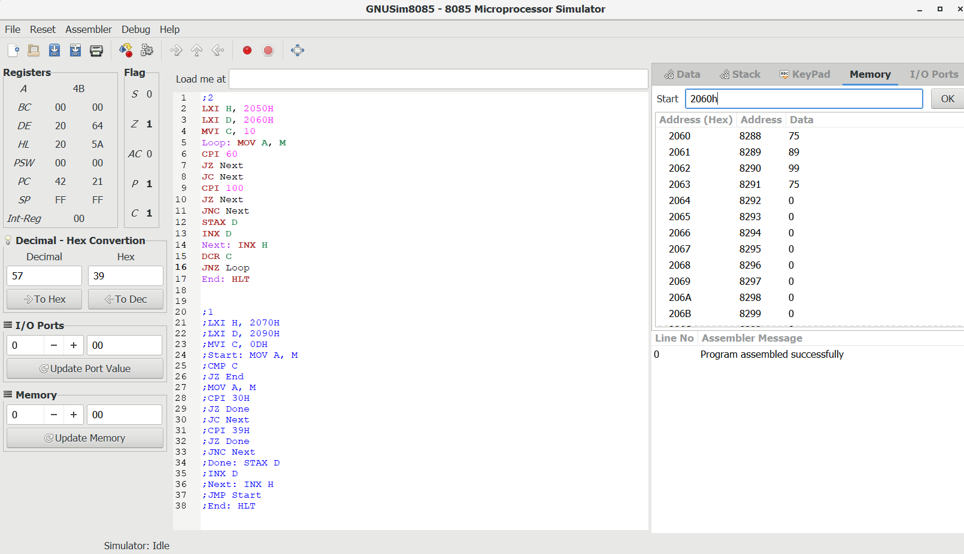

**3->** Data bytes are stored in memory locations from 2050H to 205FH.To insert an additional five bytes of data, It is necessary to shift the data string by five memory locations. Write a program to store the data string from 2055H to 2064H.Use any sixteen bytes of data to verify your program.

**MVI C, 10H**

**LXI D, 2064H**

**LXI H, 205FH**

**LOOP: MOV A, M**

**STAX D**

**DCX D**

**DCX H**

**DCR C**

**JNZ LOOP**

**; 0 at 2050H-2054H**

**MVI A, 0**

**MVI C, 5**

**Loop: STAX D**

**DCX D**

**DCR C**

**JNZ Loop**

**HLT**

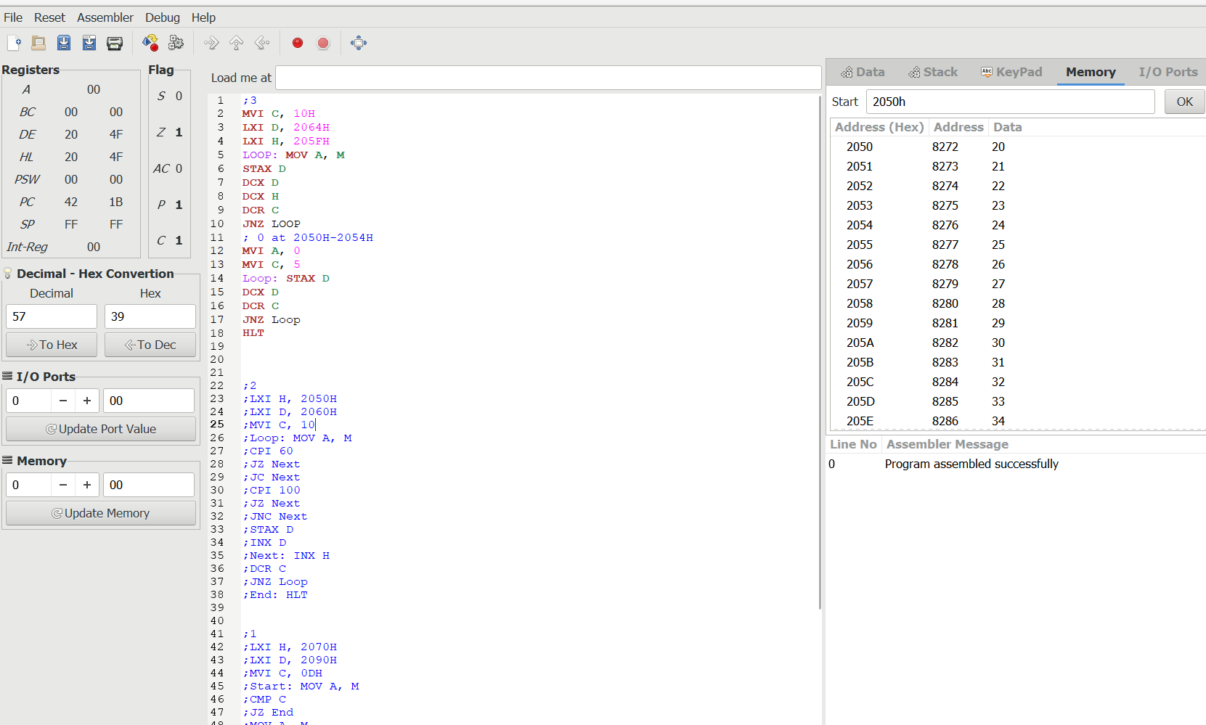

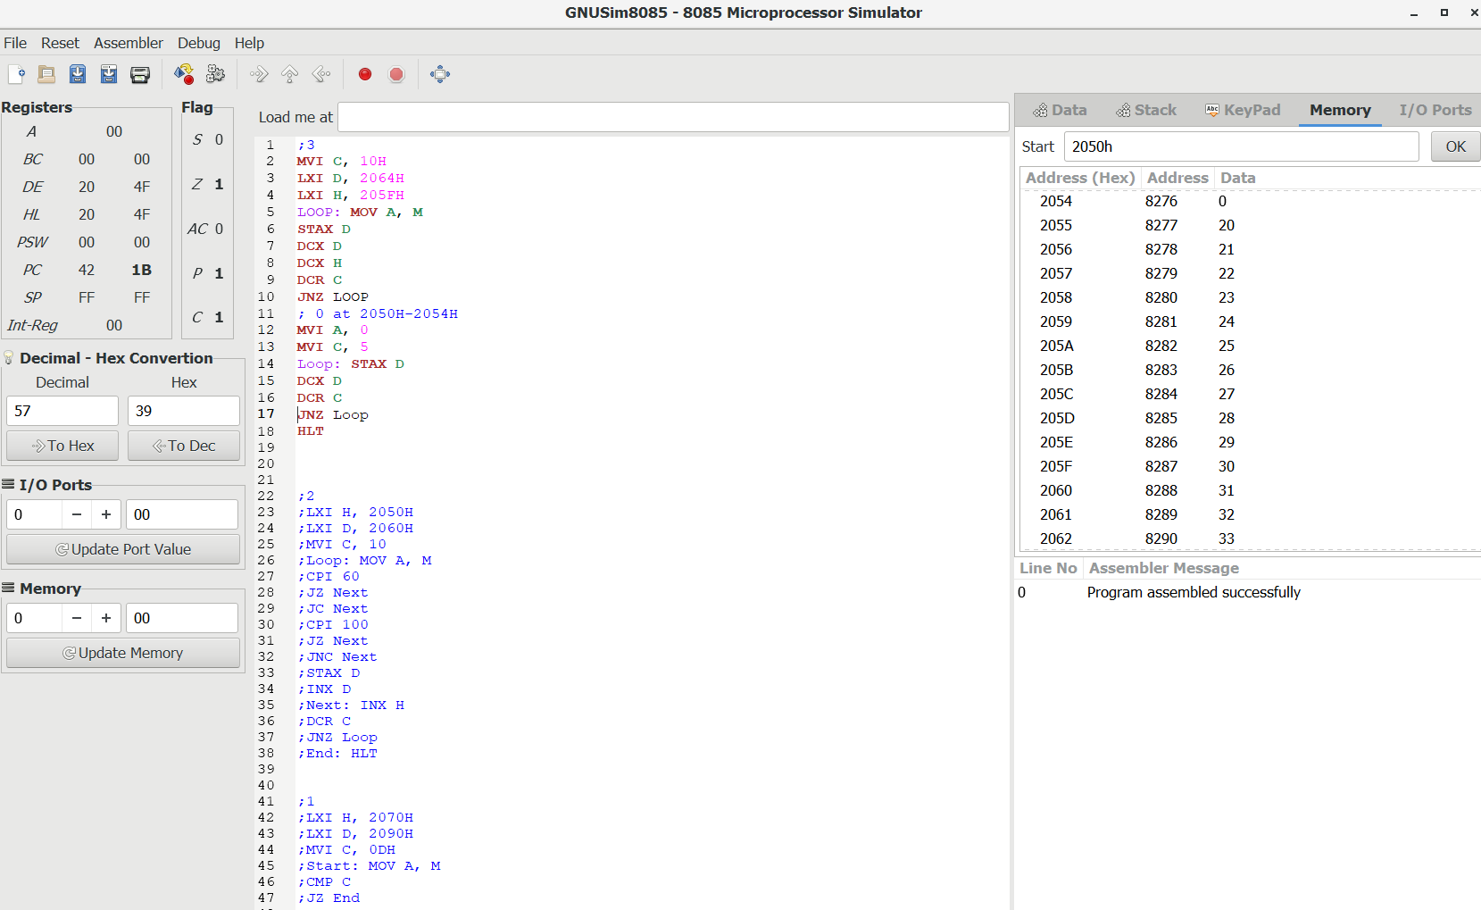

**4->** Write a Program to Sort the array in ascending order/descending order.

**Code:-**

**start: lxi H,1FFFH ; contains counter**

**mvi d,00H**

**mov c, m**

**dcr c**

**inx h**

**loop: mov a,m**

**inx h**

**cmp m ; compare with last element**

**jz next ; if equal no need to swap**

**jc next ; if less then no need to swap**

**;jnc next <===== comment above and uncomment for descending order**

**; greater then need to swap**

**mov b,m**

**mov m,a**

**dcx h**

**mov m,b**

**inx h**

**mvi d,01H ; set check swap happen**

**next: dcr c**

**jnz loop**

**mov a,d**

**cpi 01H ; if swap happen repeat the process**

**jz start**

**hlt**

**Before Sort**

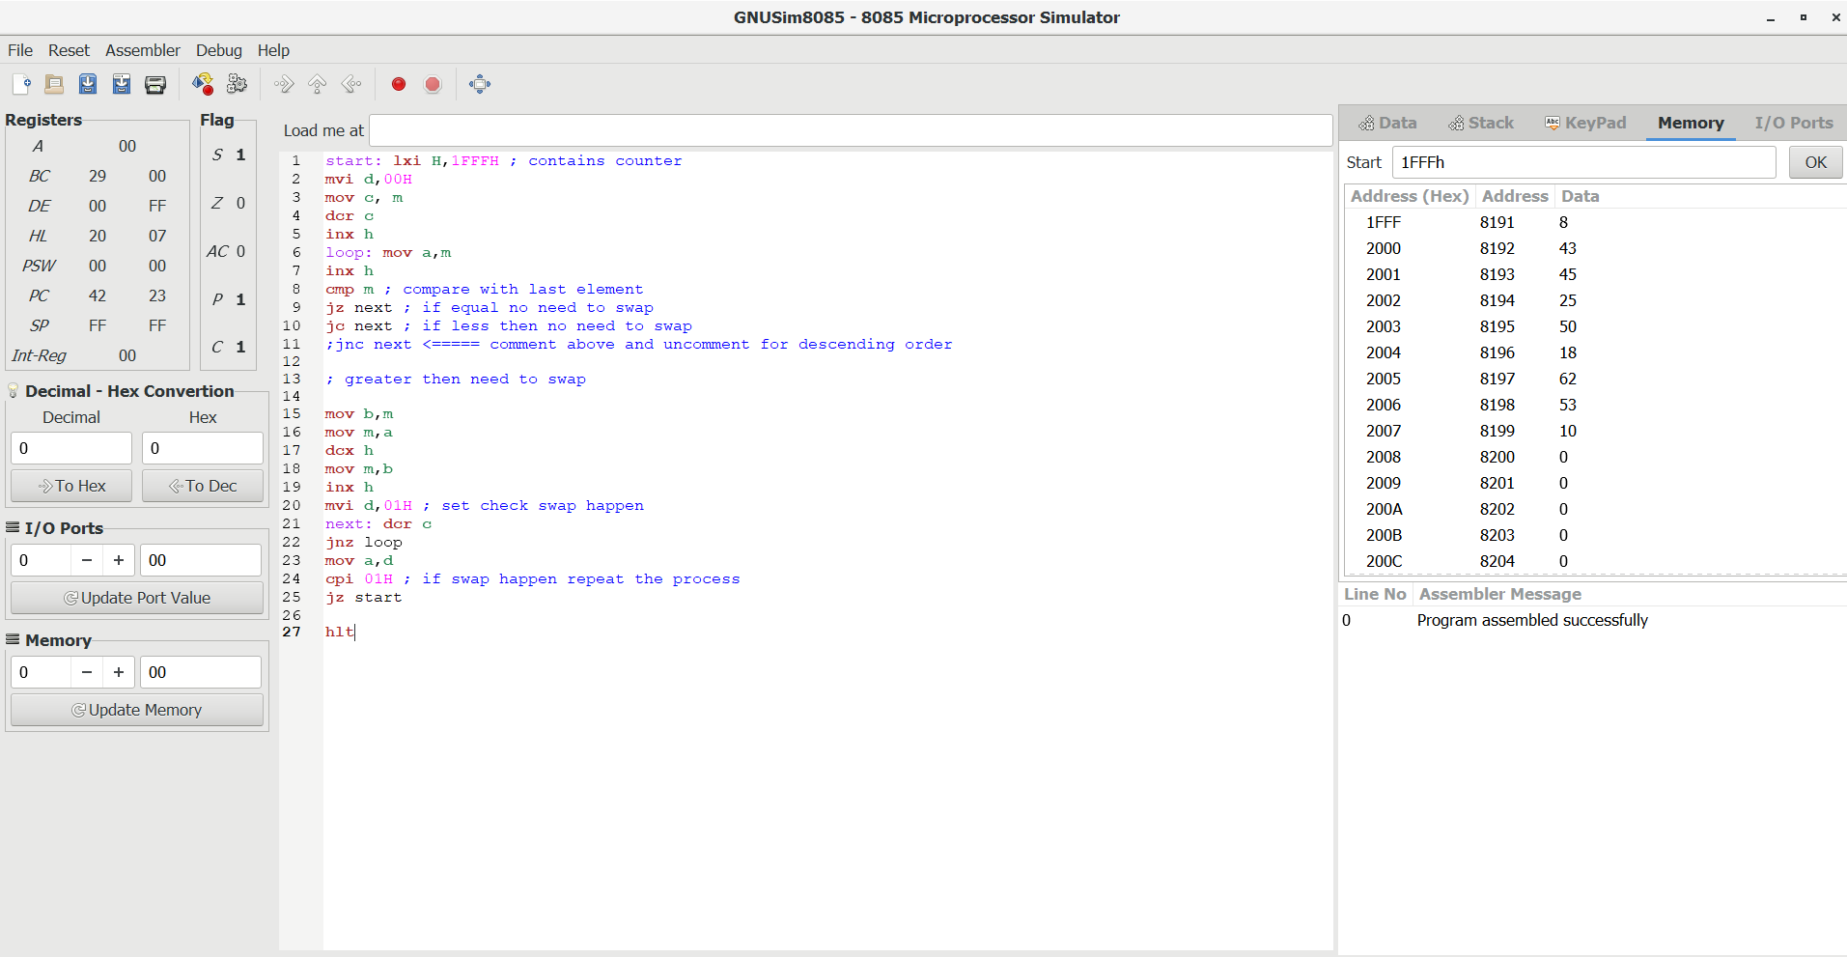

**After Sort**

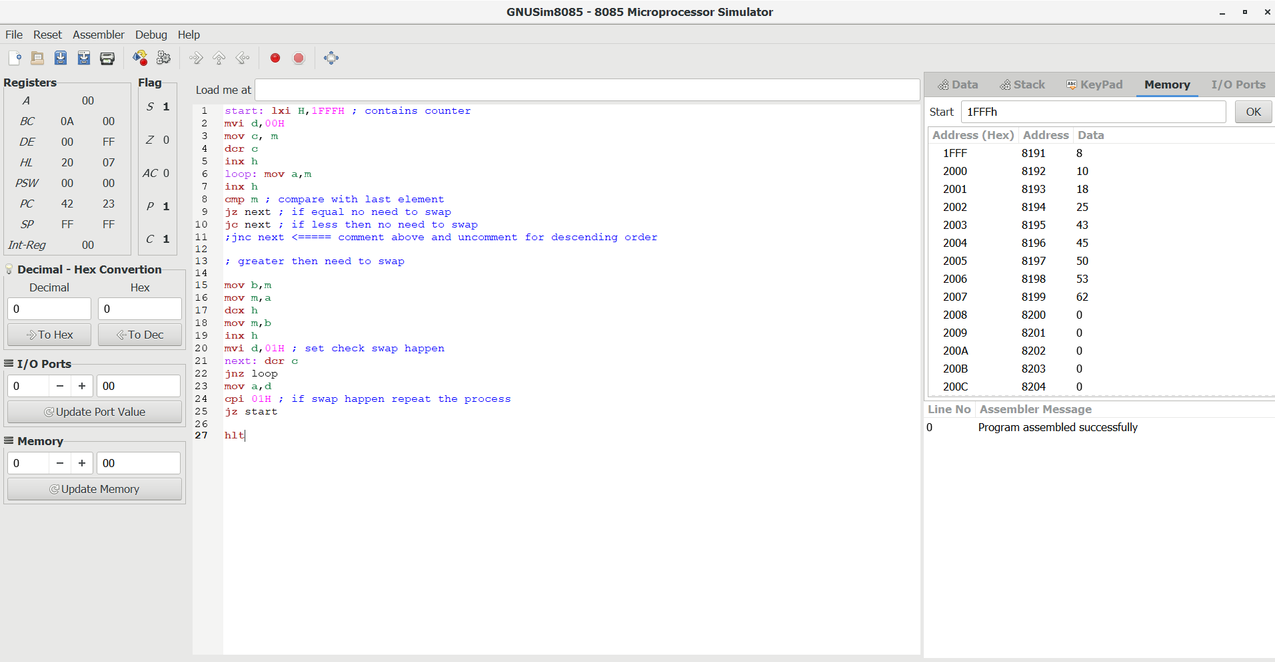

**5->** Write a Program to find Largest number in a given data array.

**Code:-**

**LDA 0000H**

**MOV C, A**

**DCR C**

**LXI H, 0001H**

**MOV B, M**

**Loop: INX H**

**MOV A, M**

**CMP B**

**JC Here**

**MOV B, A**

**Here: DCR C**

**JNZ Loop**

**INX H**

**MOV M, B;**

**HLT**

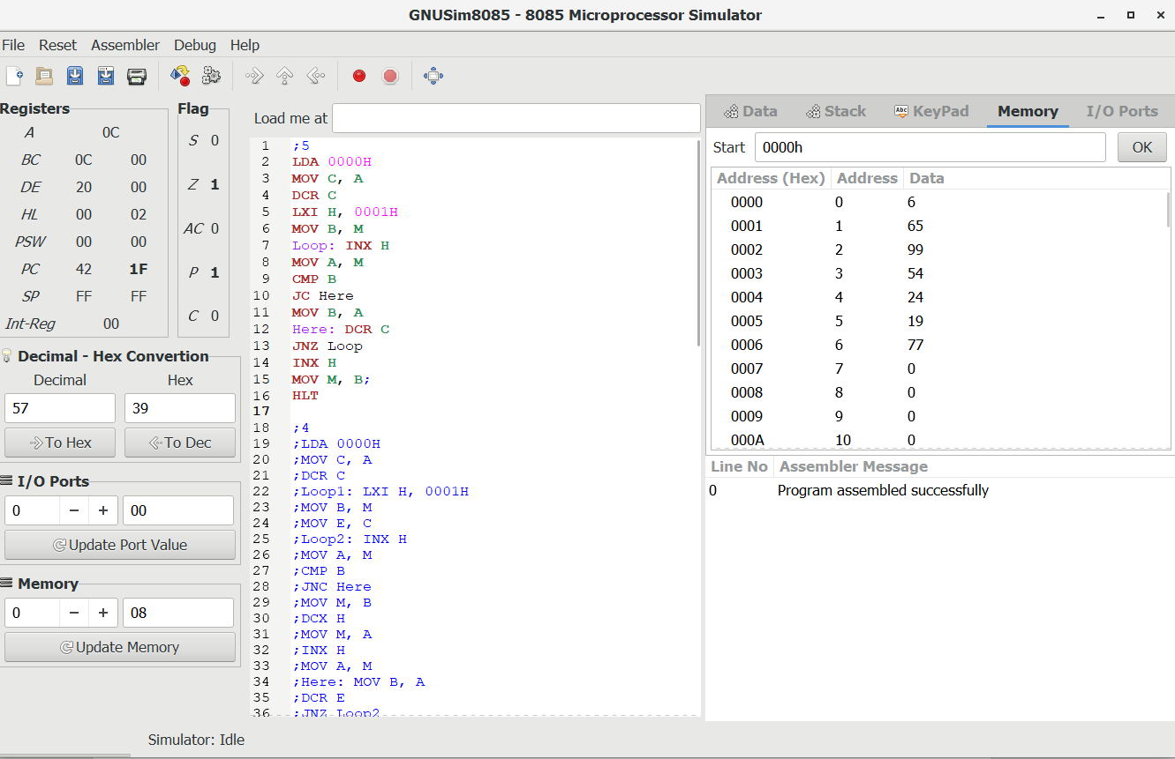

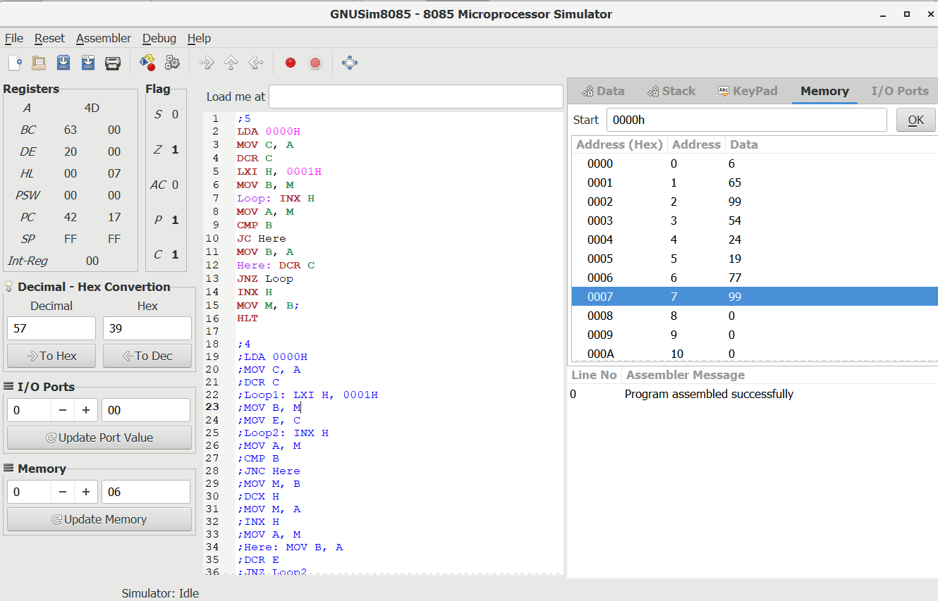

**6->** Write a Program to move a block starting at location 2000H To location 3000H with overlap/without overlap.

**Code:-**

**lxi h,1FFFH**

**mov c,m ;store block size**

**inx h ; first data byte of the source**

**lxi d,3000H ; destination address**

**mvi b,00H**

**dad b ; HL <- HL + BC(counter)**

**dcx h ; Point to the last of source**

**xchg**

**dad b**

**dcx h ; point to the last of destination**

**xchg**

**loop: mov a,m**

**stax d**

**dcx h**

**dcx d**

**dcr c**

**jnz loop**

**hlt**

